Avian Influenza restriction zone
0
9
1
4
1
2
0
2
1
0

Outbreak of avian influenza virus type A of subtype H5 has been registered in the Nemyriv district of Vinnytsia region.
Coordinates of the outbreak: 4, A. Movchana str., village Bugakiv, Nemyriv district, Vinnytsia region (48.900101, 28.955864).
Zoning was applied, by the Decision of the State Emergency Antiepizootic Commission (SEAC) of the Nemyriv district State Administration dated 20.01.2020 No. 02 restrictions were imposed.
Outbreak boundaries of PE "Khutir", LLC "Nemyriv-Podillya", JSC "Kolosok" 4, A. Movchana str, Bugakov village of the Nemyriv district of the Vinnytsia region.
The epizootic outbreak includes: PE "Khutir", LLC "Nemyriv-Podillya", JSC "Kolosok" (address 4, A. Movchana str, Bugakiv village of the Nemyriv district of the Vinnytsia region).
№ | Registration № | Operating permit  № | Name, Type of activity, Type of animal, GPS coordinates
1. | 02-14-19 | 02-14-19 EGG | PE "Khutir", JSC "Kolosok", poultry farm (laying hens)  48⁰ 90’13’’ north latitude. 28⁰ 95’87’’east longitude.
2. | 02-14-41 | a-UA-02-14-41-X-PP-РС | Nemyriv - Podillya LLC, poultry farm (laying hens)  48⁰ 90’13’’ north latitude 28⁰ 95’87’’east longitude

The protection zone covers the territory around the epizootic outbreak with radius of 3 km, that includes the municipalities: Bugakiv village, Ozero village, Zarudyntsi village, Yosypenky village, Karolina village, Zelenianka village, Vovchok village, Chukiv village, Horodnytsia village, Korzhivka village of the Nemyriv district of the Vinnytsia region.
№ | Registration № | Operating permit  № | Name, Type of activity, Type of animal, GPS coordinates
1. | - | - | -
2. | - | - | -

The surveillance zone covers the territory around the epizootic outbreak with radius of 10 km, that includes the municipalities: Monastyrok village, Rachky village, Selevintsi village, Danylky village, Korovayna village, Kryklivtsi village, Sorokotiazhyntsi village, Sazhky village, Budky village, Chervone village, Samchyntsi village, Novi Obyhody village, Korzhiv village, Hranitne village, Dovzhok village, Vovchok village, Monastyrske village, Perepelychcha village, Vyhnanka village, Ostapkivtsi village, Sholudky village, Velyka Bushynka village, Berezivka village, Melnykivtsi village, Slobidka village, Maryanivka village, Salyntsi village, Sorokoduby village, Hrabovets village, Bratslav village, Nemyriv City (partly) of the Nemyriv district of the Vinnytsia region.

№ | Registration № | Operating permit  № | Name, Type of activity, Type of animal, GPS coordinates
1. | r-UA 02-14-500 | - | JSC "Nemyrivske", poultry farm for growing waterfowl (ducks)  48⁰ 82’98’’ north latitude 28⁰ 91’44’’ east longitude
2. | - | - | -

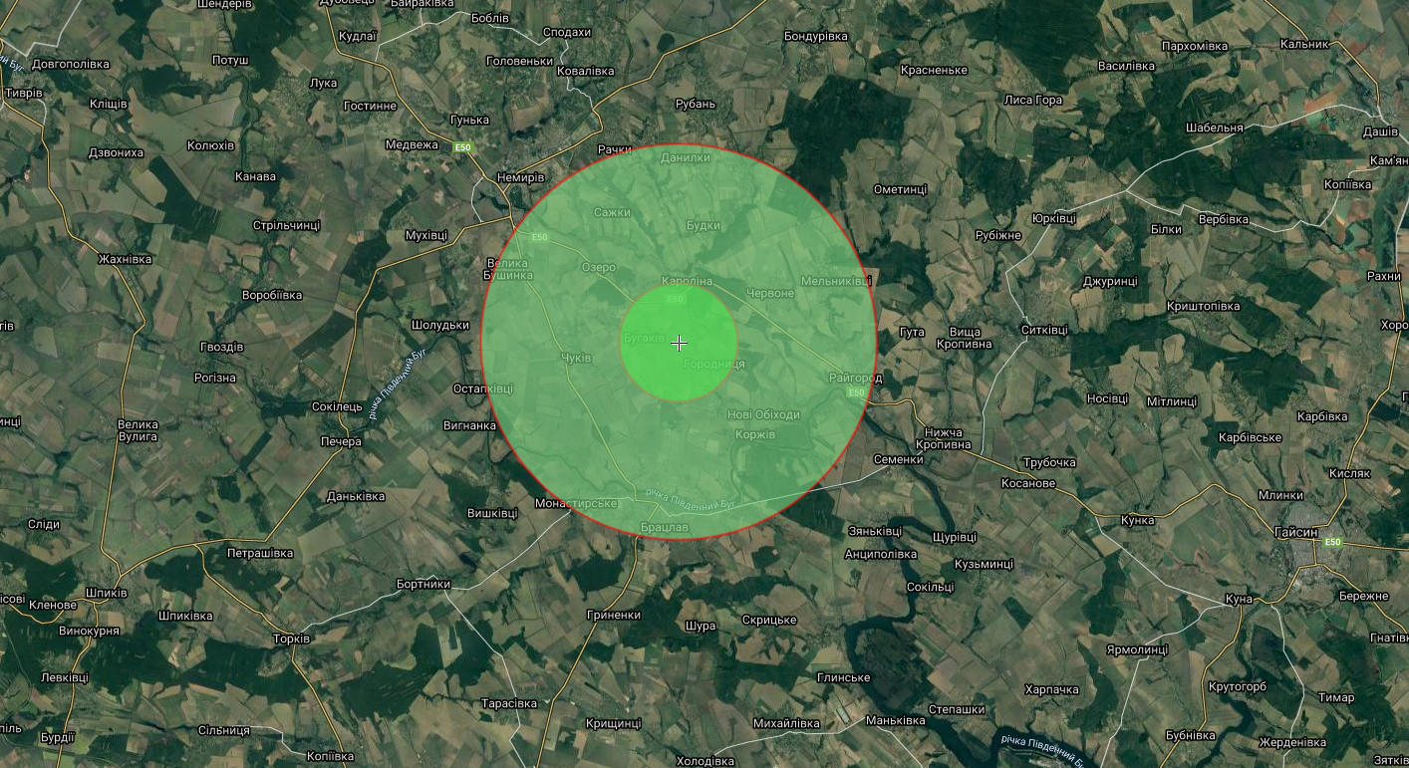
Зона обмежень 0214-190120
Причина: грип птиці.

