AVIAN INFLUENZA RESTRICTION ZONE

№
1 |  | 4 |  | 0 |  | 4 | - | 1 |  | 2 |  | 1 |  | 0 |  | 2 |  | 1

Outbreak of avian influenza virus type A1 of subtype H5 has been registered in the Voznesensk (Yelanetskyi) district of Mykolayiv region
The coordinates of the outbreak: 3, Brativ Josaniv str., Velykoserbulivka village, Voznesensk (Yelanetskyi) district, Mykolayiv region (47°41'45.7"N 31°40'51.5"E).
Zoning was applied, by the Decision of the State Emergency Antiepizootic Commission (SEAC) of the Voznesensk district State Administration dated 12.10.2021 No. 5 quarantine restrictions were imposed.
The epizootic outbreak includes: Velykoserbulivka village, Voznesensk district, Mykolayiv region
There are no commercial establishments for keeping and slaughtering of poultry in the epizootic outbreak.
№ | Registration № | Operating permit № | Name, Type of activity, Type of animal, GPS coordinates
1. | ------- | ------- | -----------

The protection zone covers: territory around the epizootic outbreak site with radius of 3 km, including following localities: Novovolodymyrivka village of Voznesensk district of Mykolayiv region.
There are no commercial establishments for keeping and slaughtering of poultry in the territory of protection zone.

№ | Registration № | Operating permit № | Name, Type of activity, Type of animal, GPS coordinates
1. | ------ | ------ | --------------

Surveillance zone includes the territory around the epizootic outbreak site with radius of 10 km, including following localities: Mykhailivka village, Hryhorivka village, Velyka Solona village, Malosolone village, Mykilske village, Yasna Poliana village, Nadezhdivka village and Ivanivka village of Voznesensk district of Mykolayiv region.
There are no commercial establishments for keeping and slaughtering of poultry in the territory of surveillance zone.
№ | Registration № | Operating permit  № | Name, Type of activity, Type оf animal, GPS coordinates
1. | -------- | --------- | ---------

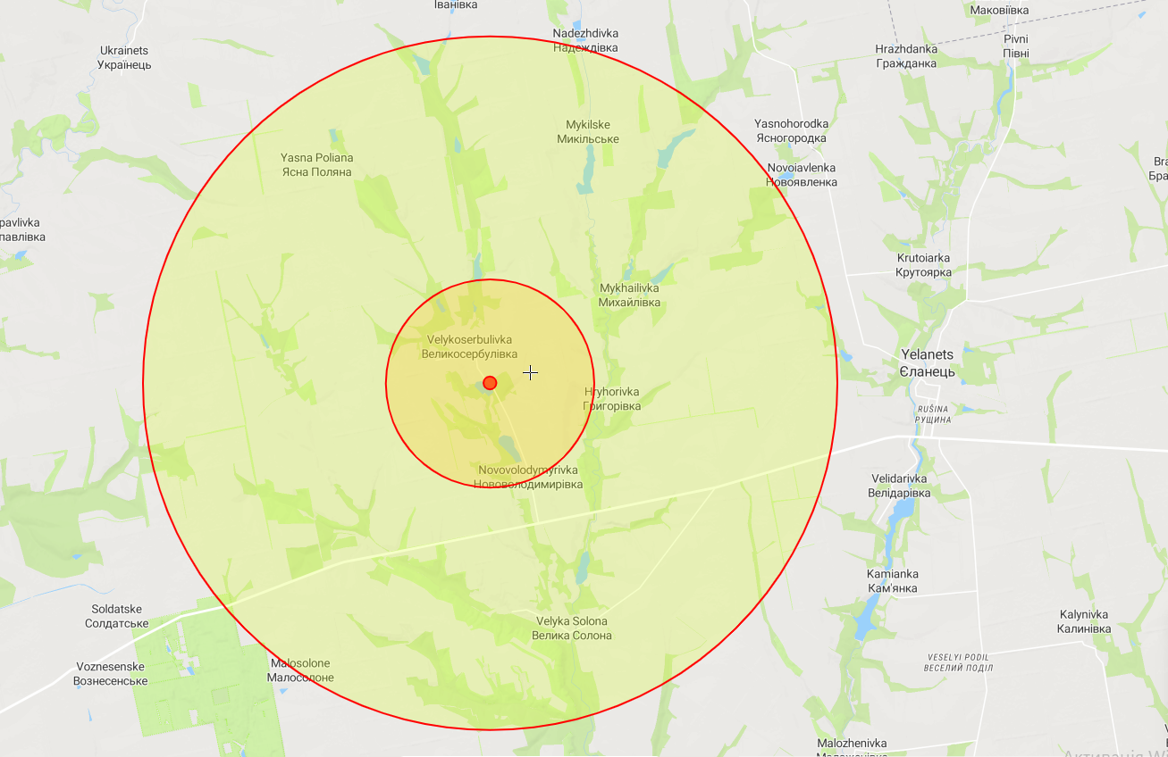

Restriction zone: 1404-121021
Reason: Avian Influenza

