AVIAN INFLUENZA RESTRICTION ZONE

№
1 |  | 0 |  | 2 |  | 2 | - | 2 |  | 8 |  | 1 |  | 2 |  | 2 |  | 0

Outbreak of avian influenza virus type A1 of subtype H5 has been registered in the Borodianka district of Kyiv region.
The coordinates of the outbreak is (50.651308788796584, 29.955885913342545) 193, Tsentralna str., Borodianka town of Borodianka district Kyiv region.
Zoning was applied and restrictions were imposed by the Decision of the State Emergency Antiepizootic Commission (SEAC) of the Borodianka district State Administration dated 28.12.2020 No. 7.
The epizootic outbreak includes 193, Tsentralna str., Borodianka town of Borodianka district Kyiv region with following coordinates 50.651308788796584, 29.955885913342545.
There are no commercial establishments for keeping and slaughtering of poultry in the epizootic outbreak.
№ | Registration № | Operating permit № | Name, Type of activity, Type of animal, GPS coordinates
1. | ------- | ------- | -----------

The protection zone covers: territory around the epizootic outbreak site with radius of 3 km, includes Borodianka town of Borodianka district of Kyiv region.
There are no commercial establishments for keeping and slaughtering of poultry in the territory of protection zone.

№ | Registration № | Operating permit № | Name, Type of activity, Type of animal, GPS coordinates
1. | ------ | ------ | --------

Surveillance zone includes the territory around the epizootic outbreak site with radius of 10 km, including following localities: Kachaly village, Shybene village, Nebrat village, Nove Zalissia village, Berestianka village, Zdvyzhivka village, Babyntsi village, Buda-Babynetska village, Klavdiyevo-Tarasove town, Poroskoten village, Pylypovychi village, Nova Hreblia village, Vablia village, Druzhnia village, Halynka village, Zahaltsi village, Mykhailivskyi (Mykhailenkiv) village, country estate “Blyzhni sady” of Borodianka district of Kyiv region.
There are commercial farms for keeping and slaughtering of poultry in the territory of surveillance zone: Farm holding “Veles Foods”, 16 A/6, Kooperatyvna str., Kachaly village of Borodianka district; LLC “Production and Trading Company “Ranko”, 59 A, Kozatska str, Babyntsi village of Borodianka district; LLC “Nuvel”, 24 A, Luhova str., Nove Zalissia village of Borodianka district.

№ | Registration № | Operating permit  № | Name, Type of activity, Type оf animal, GPS coordinates
1. | r-UA-10-22-517 | --------- | Farm holding “Veles Foods” poultry farm (broilers), 50.689483, 29.854885
2. | r-UA-10-22-355 | а-UA-10-22-29-0-CS-II-SH, CP-V-MM, MP, MSM | LLC “Production and Trading Company “Ranko” poultry farm (turkeys)  50.635106, 30.004347
3. | r-UA-10-22-354 | а-UA-10-22-31-0-CS-II-SH, CP | LLC “Nuvel” poultry farm (ducks), 50.697935, 29.961694

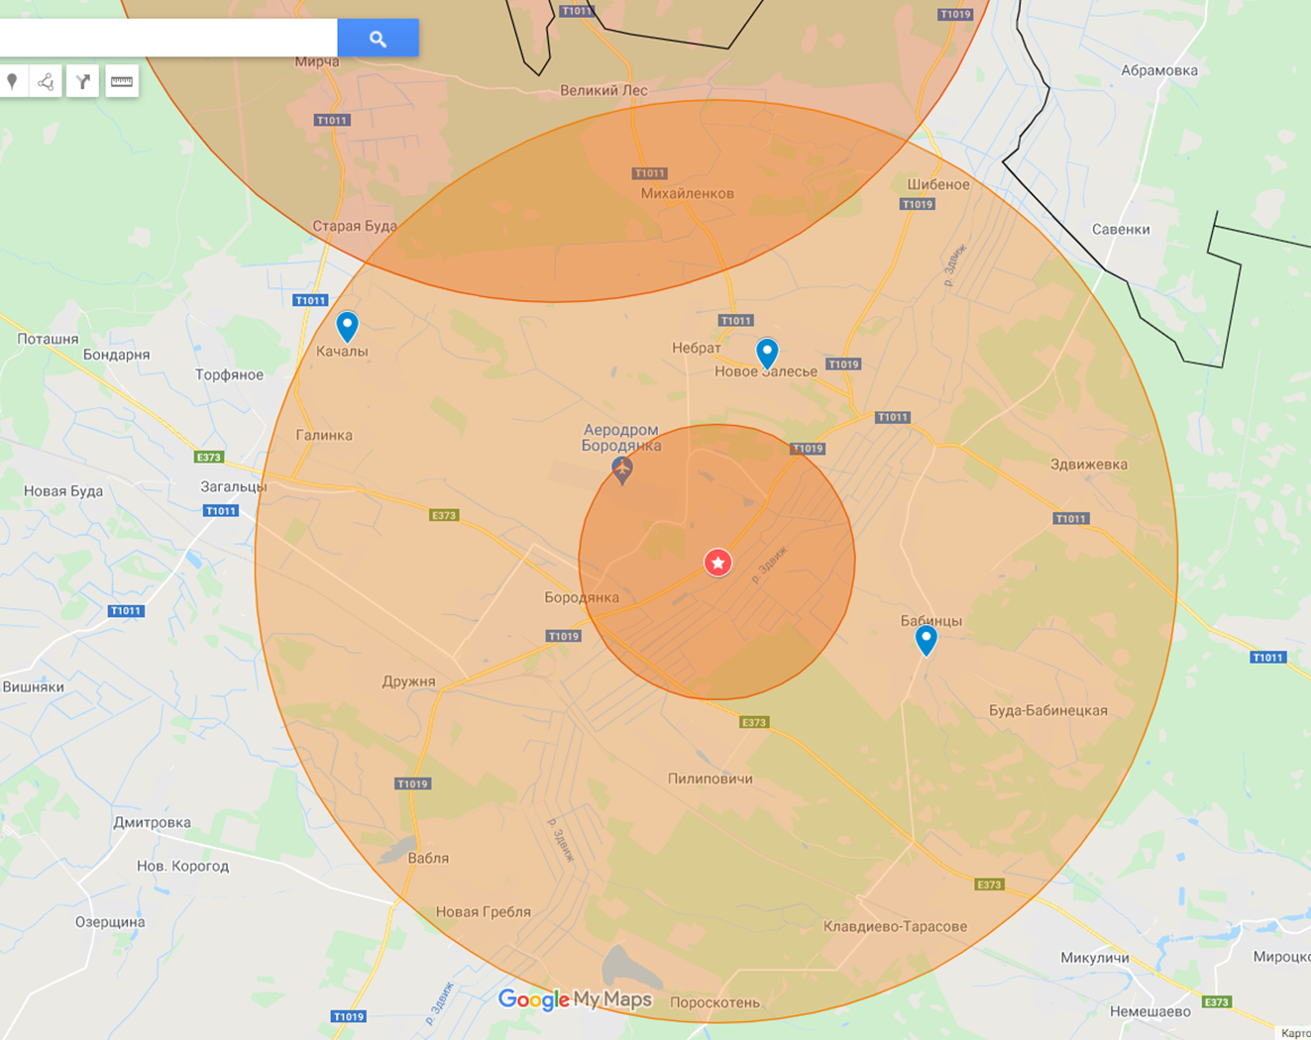

Restriction zone: 1022-281220
Reason: Avian Influenza

